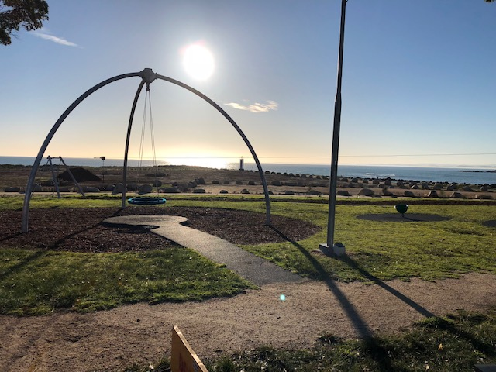
DORSET COUNCIL


Version: May 2024
Adopted by Council: 20 May 2024
Minute 95/24
PLAYGROUND AUDIT

Version: May 2024

1. OVERVIEW
There are 25 playgrounds across 11 localities within the Dorset municipality. Together they represent significant Council investment that is required to be properly managed to ensure that the needs of the community continue to be met and ensure the best value for the available resources.
Playgrounds are a critical component within communities as they provide opportunities to engage in active recreation outside of organised sports and to develop coordination, strength and motor skills. While sport is the backbone of regional communities playing may not be accessible, affordable or desirable for many. With more than one quarter (28.7%) of Tasmanian children identified as overweight or obese and physical activity a key component to a healthy lifestyle, low/no cost active recreational opportunities are more important than ever for communities.
Play supports the holistic development of children by improving cognitive, physical, social and emotional wellbeing. As play changes as children grow and develop it is imperative that we balance the target age of equipment to cater for a broad age range and a diverse mix of equipment styles. By ensuring that not only does the equipment promote play but also encourages imagination and creativity we can influence the physical and mental health and wellbeing of young people within the community and assist with laying the foundations for healthy, resilient adults.
Playgrounds should ideally be inclusive, engaging and safe, allowing children and young people to take risks in a controlled environment. As they act as informal meeting places for children and families to interact it is also ideal that playgrounds, particularly in rural spaces, are developed further as social, family and recreation spaces to provide space for informal gatherings, relaxation and play rather than just single purpose play parks where possible. These multi use green spaces are a key element in promoting community liveability and developing positive health outcomes.
The Dorset Council Playground Audit was identified as a key project as part of the Dorset Council Priority Projects Plan 2023-2025 and was developed in order to identify gaps and opportunities and inform decisions for the strategic upgrade and development of existing and future facilities.

2. METHODOLOGY
This Playground Facility Audit has been undertaken in three stages:

Stage 1: Inventory and Playground Review - A desktop analysis was conducted to identify the equipment elements in each playground and gather information regarding age of equipment and approximate lifespan. Equipment was attributed to a target age group/s based on manufacturer’s recommendation and grouped by individual play space. Annual maintenance audits were reviewed and site inspections conducted where necessary to determine equipment condition.
Stage 2: Community Consultation - A community consultation process was conducted from Wednesday 31st October to Friday 8th December. The consultation consisted of:
- Staff Consultation – Works and Infrastructure staff were consulted in order to understand gaps and opportunities from a maintenance and construction perspective.
- Online Community Survey: A total of 31 responses were received via the online survey.
- Design a Playground Competition: A total of 24 entries were received from young people across the municipality for the competition.
Stage 3: Consolidation of Information and Report Development - Information was collated and analysed prior to being presented as a report.
The aim of the Audit process was to provide:
- an itemised inventory of the equipment, including age, lifespan and target demographic
- demographic information for the locations of playgrounds
- community consultation into usage and equipment style to inform future upgrades
- guidance for the systematic investment in upgrades
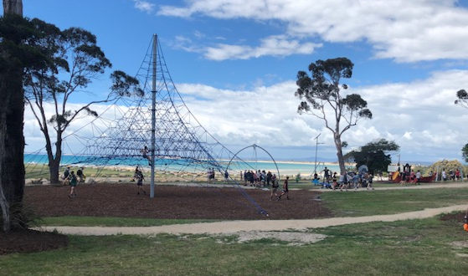

3. PLAYGROUND REVIEW
Dorset playgrounds cater for a variety of age groups with each age group requiring a different element of equipment and play space. This report has utilised the following breakdowns to ensure consistency during the audit.
Infant/Toddler—Ages 0-2: Low/ground level play structures, gentle slides, interactive spaces to encourage sensory exploration, and fine motor skill development.
Toddler/Infant—Ages 3-5: Greater challenges for motor, social and sensory development.
School Age—Ages 6-12: More challenging climbers, taller slides, dynamic net play structures and exhilarating zip lines that promote physical coordination, social skills and cognitive engagement.
Teen and Adult—Ages 13+: Fitness circuits, ninja warrior courses that challenge at a more adult level.
Accessible—All ages: Wheelchair accessible, sensory equipment etc.

The following is a breakdown of the demographics within each locality and the playgrounds and equipment located within it.

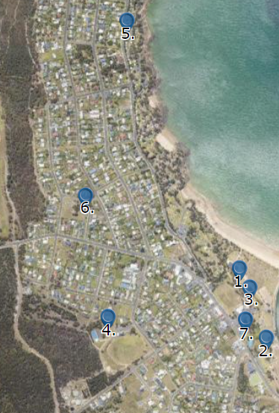
BRIDPORT
0-4 year olds | 94
5-9 year olds | 85
10-14 year olds | 107
15-19 year olds | 64
TOTAL CHILDREN AND YOUNG PEOPLE  (Increase of 30 since 2016) | 350
TOTAL NUMBER OF RESIDENTS  (Increase of 174 since 2016) | 1742
(2021 Census Data)

There are 7 playground spaces throughout Bridport:

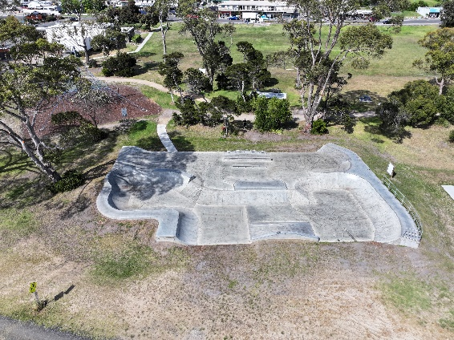
Bridport Foreshore (Skate Park area)
This area consists of a brand new skate park (completed in 2022), half-court basketball (completed in 2023) and several pieces of exercise equipment.
The play space is well utilised and as it is adjacent to the popular Lions Adventure Playground provides a value add to cater for older children and teenagers in the area.
Toilets, drinking water and parking are all located approximately 100m away adjacent to the Lions Adventure Playground. Access is relatively flat along a gravel path.
Play space is unfenced and situated between 10 and 15m from the dirt access road to the Surf Lifesaving Club and Goftons Beach.
Equipment | Installed | Target Age Group
Equipment | Installed | 0-2 | 3-5 | 6-12 | 13+ | A
Skate Park | 2022
Exercise Equipment | 2022
Basketball Half Court | 2023

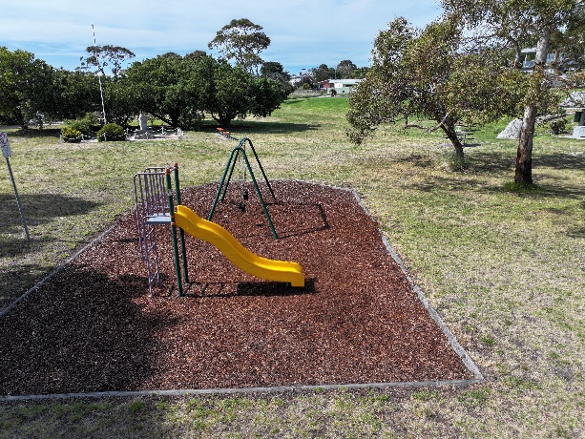
Bridport Foreshore (Opposite RSL)
The playground area consists of a swing and slide. The equipment is in average condition and due for an upgrade. The space is located 300m away from the popular Lions Adventure. Parking is available 50m away but access is via stairs or a steep grassed bank. Toilets, drinking water and alternative parking are located approximately 250m adjacent to the Lions Adventure Playground with access via a gravel path.
Playground is unfenced but situated over 40m away from Main Street and down a steep bank.
Equipment | Installed | Target Age Group
Equipment | Installed | 0-2 | 3-5 | 6-12 | 13+ | A
Slide | 2001
Double Swing | 2004

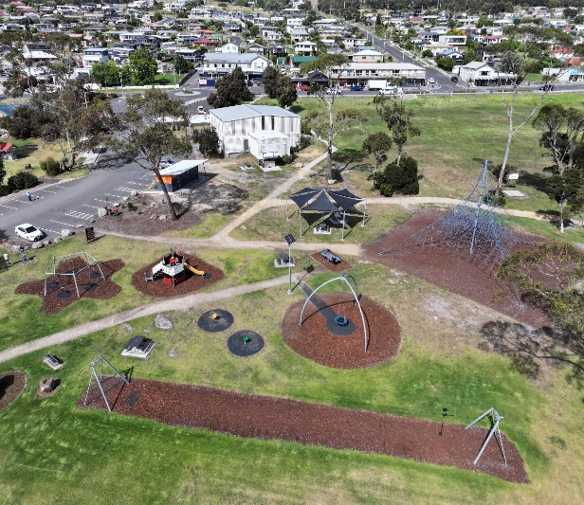
Lions Adventure Playground
The playground has a broad selection of equipment and is very well utilised. For future equipment, options focus should be on younger age groups and on including more accessible play options to cater for those with a disability.
Parking, drinking water and toilets plus BBQ’s are located at the Lions Adventure Playground. Access is flat along gravel paths.
Playground in unfenced and situated 8m from busy carpark and 15m from a dirt access road to the Surf Lifesaving Club and Gofton’s Beach.
Equipment | Installed | Target Age Group
Equipment | Installed | 0-2 | 3-5 | 6-12 | 13+ | A
Flying Fox | 2018
Dolphin/Shark Rocker | 2018
Birds Nest Swing | 2018
Green Spin Seat | 2018
Yellow Spin Seat | 2018
Boat and Slide | 2018
5 Seat Swing Combo | 2018
Climbing Hexagon | 2018
Space Net Climbing Frame | 2018

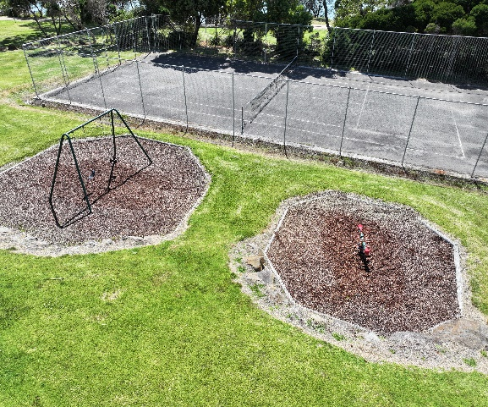
Bentley Street Playground
This playground consists of a swing set and a spring toy both of which are overdue for upgrade.
Toilets are located 250m away at the Old Pier boat ramp. Parking is available 3m adjacent to the playground. Access to the playground is flat.
Playground in unfenced and situated 7m from road (Bentley Street).

Equipment | Installed | Target Age Group
Equipment | Installed | 0-2 | 3-5 | 6-12 | 13+ | A
Double Swings | 2005
Spring Toy (Junior Rocker) | 2005
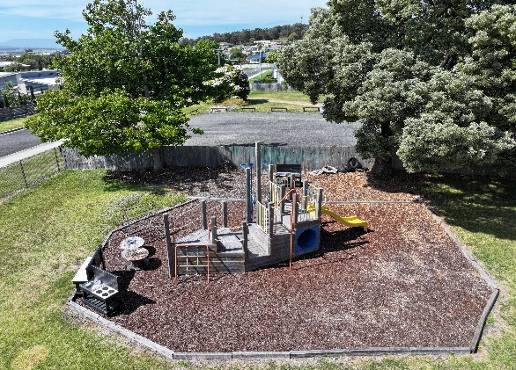
Play Centre (Joseph Street)
This playground is part of the Bridport Play Centre which is utilised by Bridport Girl Guides and Playgroups.
Parking, toilets and drinking water all available onsite.
Playground is fenced.

Equipment | Installed | Target Age Group
Equipment | Installed | 0-2 | 3-5 | 6-12 | 13+ | A
Swings | Unknown
Boat Slide Combination Equipment | Unknown

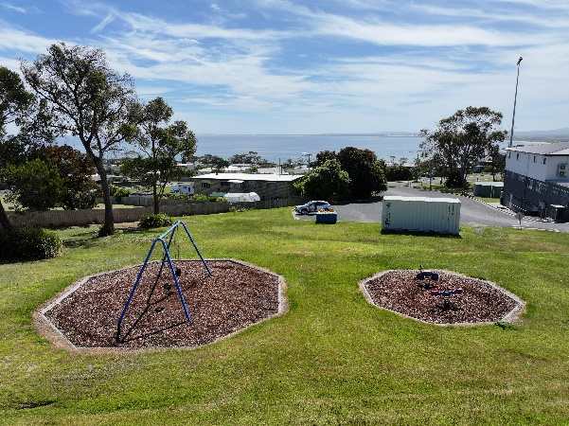
Bridport Recreation Ground Playground
This playground consists of a double swing and two spring rockers.
Toilets, parking and drinking water is all located at the Bridport Recreation Ground Multifunction Centre. Access is flat.
Playground is unfenced but situated 25m back from the Bridport Recreation Ground carpark.
Equipment | Installed | Target Age Group
Equipment | Installed | 0-2 | 3-5 | 6-12 | 13+ | A
Double Swing | 1999
Spring Toy (Minibike) | 1999
Spring Toy (Junior Rocker) | 2005

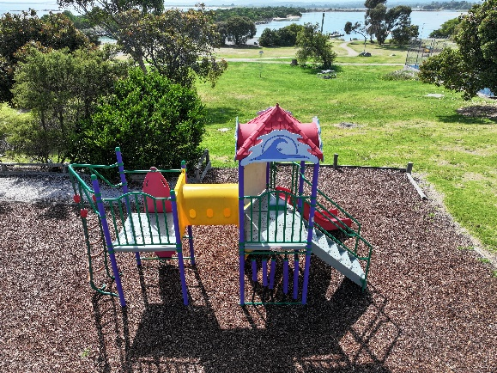
Main Street (Tennis Courts)
This playground is located directly behind the tennis court at the Visitor Information Centre and seems to be used more as an overflow if the Lions Adventure Playground is full. As this playground is coming up for renewal it could be that instead of replacing we look at instead consolidating this playground into the Lions Adventure Playground.
Toilets and parking are located 60m away at the Visitor Information Centre. Access is via a sloped grass walkway.
Playground is unfenced but situated 20m back from the road (Main Street).
Equipment | Installed | Target Age Group
Equipment | Installed | 0-2 | 3-5 | 6-12 | 13+ | A
Combination Play Equipment | 2004

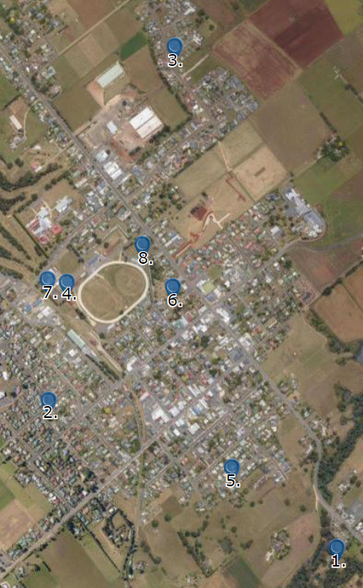
SCOTTSDALE
0-4 year olds | 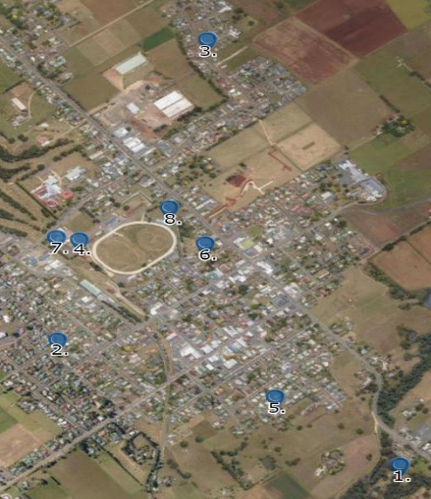  105
5-9 year olds | 124
10-14 year olds | 167
15-19 year olds | 128
TOTAL CHILDREN AND YOUNG PEOPLE  (Decrease of 45 since 2016) | 524
TOTAL NUMBER OF RESIDENTS  (Increase of 35 since 2016) | 2408
(2021 Census Data)

There are 8 playground spaces throughout Scottsdale.

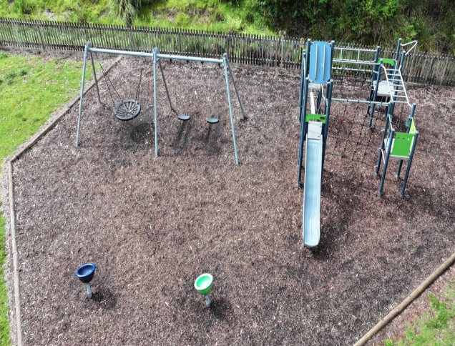
Northeast Park
Northeast Park is a popular location for locals and visitors alike with the duck pond particularly popular amongst younger children. Unfortunately the playground currently has a lack of equipment for young children in the Infant/Toddler age range.
The park has a lot of potential with the boardwalk at the rear of the park showcasing the natural assets and a stage set up providing great future opportunities for events or festivals. Both the boardwalk and the stage area are in need of attention if they are to be utilised regularly.
Toilets and parking are located at the park entry approximately 80m away. Access to the playground is via a grassed slope. BBQs and shelter are also available within the Northeast Park approximately 20m from the playground.
Playground is unfenced but set back from the main road (Ringarooma Road).
Equipment | Installed | Target Age Group
Equipment | Installed | 0-2 | 3-5 | 6-12 | 13+ | A
Birds Nest Swing Combination | 2018
Spin Seat – Blue | 2018
Spin Seat – Green | 2018
Climbing Frame and Slide | 2018

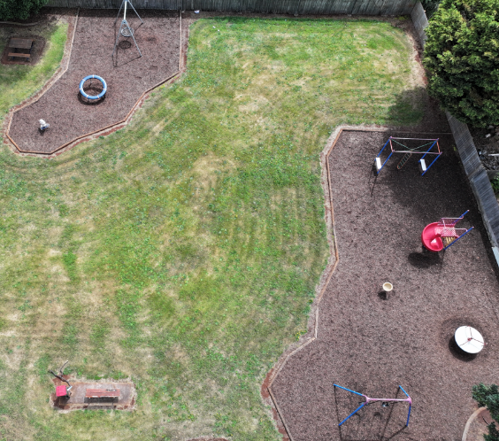
Elizabeth/Ethel Street Park
The Elizabeth/Ethel Street Park is a popular stopping place after school for families. The park has some updated equipment but there is also some that is overdue for an upgrade. This park would benefit from open ended play equipment so children can engage their imagination and creativity. There is ample space available for further options.
There is no toilets or drinking water available at the park. Parking is on street only. Playground is unfenced.
Equipment | Installed | Target Age Group
Equipment | Installed | 0-2 | 3-5 | 6-12 | 13+ | A
Birds Nest Swing | 2018
Double Swing | 2007
Plastic Ring | 2018
Spin Seat – Yellow | 2018
Carousel with Bars – Red | 2018
Spiral Slide | 2006
Spring Toy (Frog) | Unknown
Whirlpool Climbing Frame | 2006

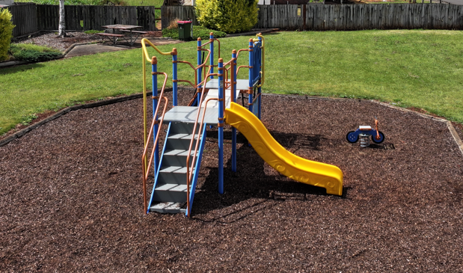
Spotswood Drive Playground
This playground is very popular due to the high number of families and children in the area. The equipment is over 20 years old. Including some younger age targeted equipment and potentially some options for teenagers would be beneficial. There is ample space to install further options.
There is no toilets or drinking water available at the park. Parking is on street only. Playground in unfenced.
Equipment | Installed | Target Age Group
Equipment | Installed | 0-2 | 3-5 | 6-12 | 13+ | A
Combination Play Equipment | 1999
Spring Toy (Minibike) | 1999

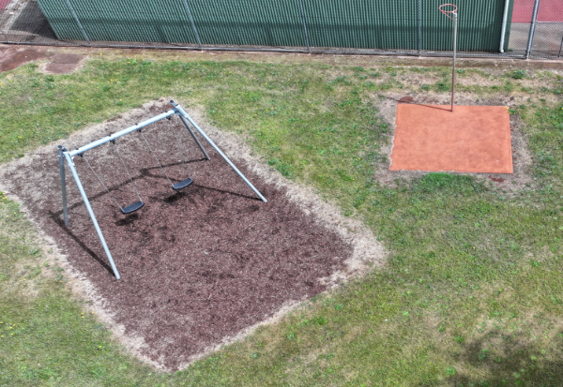
Scottsdale Recreation Ground Playground
This playground consists of a swing set and a netball hoop.
Parking is available 40m away. Toilets are 130m away and there is drinking water available 70m away. The Scottsdale Recreation Ground is due for a feasibility study to determine future direction so it is recommended not to make any changes to this area in the interim.
Playground is unfenced.

Equipment | Installed | Target Age Group
Equipment | Installed | 0-2 | 3-5 | 6-12 | 13+ | A
Double Swing | 2018
Netball Hoop | Unknown

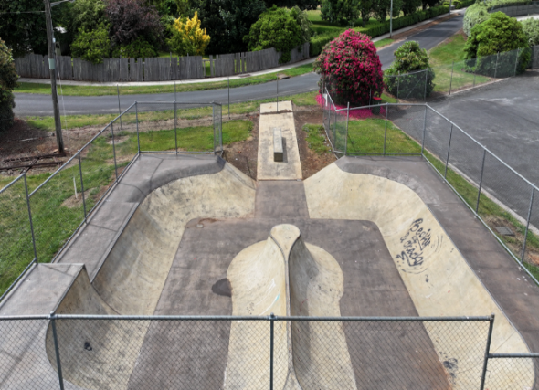
Scottsdale Skate Park
The Skate Park is underutilised due to its design and would benefit greatly from an upgrade.
Toilets are located 240m away at the Children’s Reserve or 260m away at the Rec Ground. Drinking water is available outside the netball courts 370m away. Parking is available next to the Nugget Sellers Pavilion or on street along Alfred Street. Play space is fenced.
The Scottsdale Recreation Ground is due for a feasibility study to determine future direction so it is recommended not to make any changes to this area in the interim.
Equipment | Installed | Target Age Group
Equipment | Installed | 0-2 | 3-5 | 6-12 | 13+ | A
Skate Park - Concrete | 2013
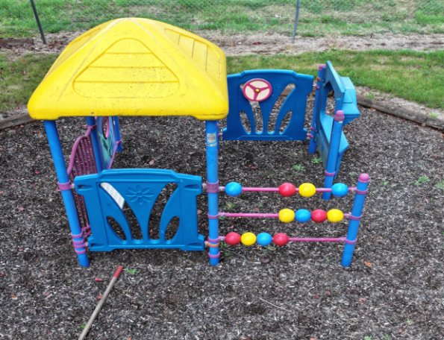
Scottsdale Tennis Courts Playground
The equipment is in good condition with the playground relatively underutilised by the public due to its location. Toilets are located internally at the Stadium
Toilets are located 370m away at the Recreation Ground (via Rose Street), parking is available adjacent to the playground. Access to the playground is flat and grassed but via a locked gate.
Equipment | Installed | Target Age Group
Equipment | Installed | 0-2 | 3-5 | 6-12 | 13+ | A
Play Fort | 2007
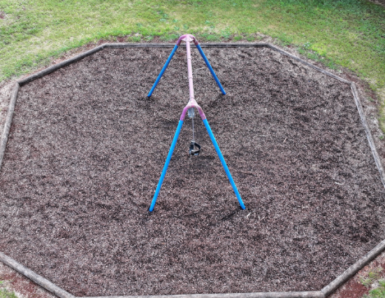
McLennan Street Playground
This playground is a double swing only.
There is no toilets or drinking water available at the park. Parking is on street only.
Playground is unfenced

Equipment | Installed | Target Age Group
Equipment | Installed | 0-2 | 3-5 | 6-12 | 13+ | A
Double Swing | 2006

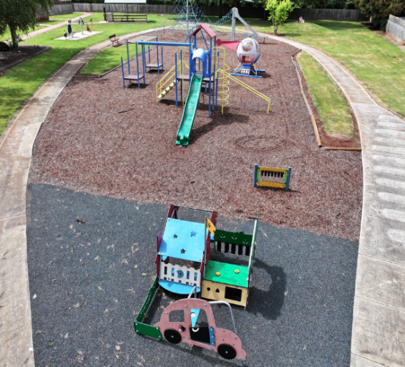
Children’s Reserve (Anzac Park)
This playground is well utilised particularly for birthday parties however a key piece for the early childhood age group is the helicopter which is dated and in need of upgrade. Consideration could be given to include pieces from both the Infant/Toddler and the Early Childhood age groups as well as Accessible play options. Further development could also take advantage of the grass mounds and the concrete bike path to create more of a ‘destination’ style playground.
Toilets and BBQ facilities are available at the park. There is no drinking water. Parking is available on George Street located 50m along a concrete footpath. Playground is unfenced but set well back from the road.
Equipment | Installed | Target Age Group
Equipment | Installed | 0-2 | 3-5 | 6-12 | 13+ | A
Space Net | 2018
Helicopter | 1995
Double Swings | 1995
Car Fort | 2016
Musical Rail | 2016
Combination and Slide | 1995
Spring Toy (Horse) | 1995
Exercise Bike | 2019
Push Up Bars | 2019
Sit Up Bench | 2019
Power Bike | 2019
Bike Track - Concrete | Unknown

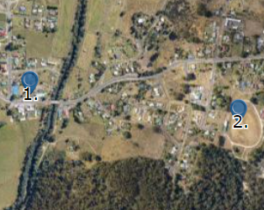
BRANXHOLM
0-4 year olds | 6
5-9 year olds | 11
10-14 year olds | 12
15-19 year olds | 14
TOTAL CHILDREN AND YOUNG PEOPLE  (Decrease of 16 since 2016) | 43
TOTAL NUMBER OF RESIDENTS  (Decrease of 31 since 2016) | 236
(2021 Census Data)

There are 2 playground spaces throughout Branxholm.

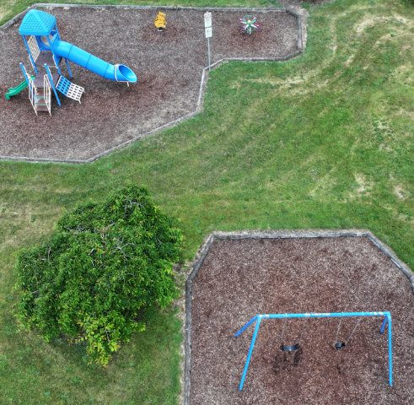
Branxholm Park Playground
The Branxholm Park receives traffic from the camping ground as well as locals and visitors and is generally well utilised. The majority of the equipment however, is well overdue for an upgrade (2017). Equipment is non-existent for the Infant/Toddler age group and is minimal for Teen/Young Adults.
Toilets and parking are located at the park. BBQ facilities are also available.
Playground is partly fenced (road frontage only)
Equipment | Installed | Target Age Group
Equipment | Installed | 0-2 | 3-5 | 6-12 | 13+ | A
Combination Play Equipment | 1997
Spring Toy (Koala) | 1997
Spring Toy (Whale) | 1997
Double Swing | 1997
Spring Toy (Starfish) | 2020
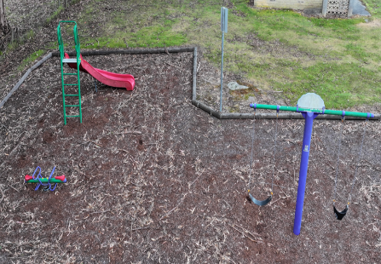
Branxholm Recreation Ground
This is a small playground consisting of a slide, double swing and spring toy. There is no toilets or drinking water available. Parking is at the recreation ground with flat access to the playground. Potential exists to consolidate this playground with Branxholm Park or relocate the equipment to another rural playground as it is no longer regularly used. Playground is unfenced.
Equipment | Installed | Target Age Group
Equipment | Installed | 0-2 | 3-5 | 6-12 | 13+ | A
Spring Toy (Junior Rocker) | 2006
Slide | 2006
Double Swing | 2006

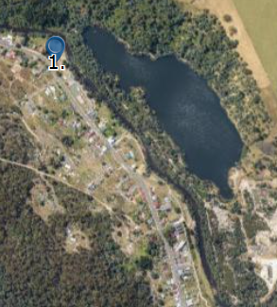
DERBY
0-4 year olds | 0
5-9 year olds | 5
10-14 year olds | 6
15-19 year olds | 9
TOTAL CHILDREN AND YOUNG PEOPLE  (Decrease of 7 since 2016) | 20
TOTAL NUMBER OF RESIDENTS  (Decrease of 64 since 2016) | 109
(2021 Census Data)
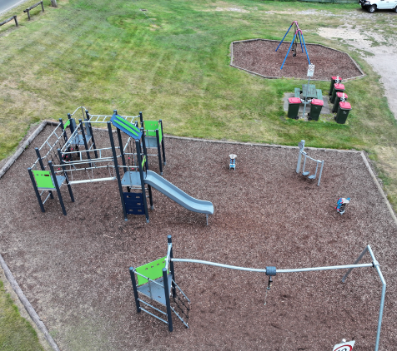
There is 1 playground space in Derby.

Derby Park Playground
The Derby Park receives significant volumes of traffic from the camping ground and has recently been upgraded. Future updates should look at options for Infant/Toddler and Accessible play equipment.
There is toilets available at Derby Park 60m away. Parking and drinking water is both available as is BBQ facilities.
Playground is unfenced and located within 10m from Main Street.
Equipment | Installed | Target Age Group
Equipment | Installed | 0-2 | 3-5 | 6-12 | 13+ | A
Spring Toy (Hen) | 2022
Spring Toy | 2022
Combination Play Equipment | 2022
Double Swing | 2007
 | 2022
Air Walker | 2010

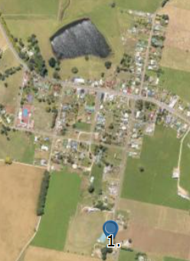
RINGAROOMA
0-4 year olds | 13
5-9 year olds | 16
10-14 year olds | 18
15-19 year olds | 19
TOTAL CHILDREN AND YOUNG PEOPLE  (Decrease of 17 since 2016) | 66
TOTAL NUMBER OF RESIDENTS  (Decrease of 1 since 2016) | 337
(2021 Census Data)
There is 1 playground space in Ringarooma.

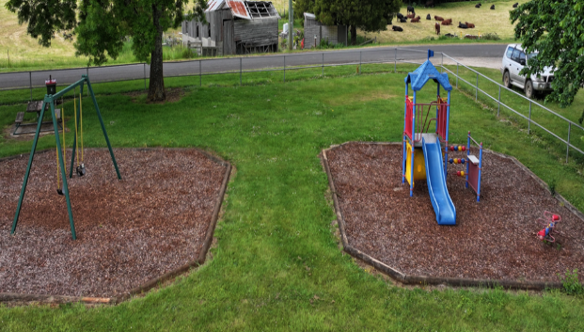
Ringarooma Recreation Ground
The Ringarooma playground is quite isolated from the main centre of Ringarooma. There is limited options for teenagers and none for Infant/Toddlers.
There is public toilets located on Main Street 900m away and parking at the Recreation Ground. Access is flat. Playground is partly fenced.
Equipment | Installed | Target Age Group
Equipment | Installed | 0-2 | 3-5 | 6-12 | 13+ | A
Combination Play Equipment | 1998
Spring Toy (Junior Rocker) | 1998
Double Swing | 2005

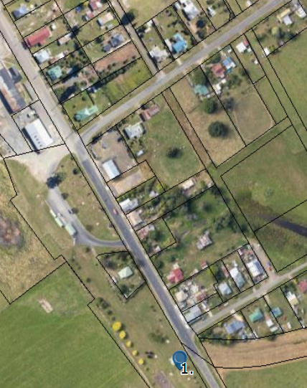
LEGERWOOD
0-4 year olds | 10
5-9 year olds | 15
10-14 year olds | 28
15-19 year olds | 12
TOTAL CHILDREN AND YOUNG PEOPLE  (Increase of 11 since 2016) | 65
TOTAL NUMBER OF RESIDENTS  (Increase of 11 since 2016) | 204
(2021 Census Data)
There is 1 playground space in Legerwood.

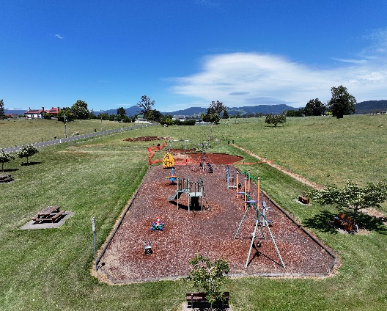
Legerwood Memorial Park
Le gerwood Memorial Park caters well for ages 2 up but has no options targeted at the Infant/Toddler age groups. Future updates should look at options for Infant/Toddler and Accessible play equipment.
An upgrade is currently underway to install two new equipment pieces.
Toilets are located 150m away at the Visitor Centre. Parking is 30m away on roadside. Access is flat. Playground is unfenced.
Equipment | Installed | Target Age Group
Equipment | Installed | 0-2 | 3-5 | 6-12 | 13+ | A
Double Swing | Unknown
Train Rocker | 2008
Amazon Play Unit | Unknown
Starfish Rocker | 2009
Climbing Frame | Unknown
Flex Station | Unknown
Stepping Machine x 2 | Unknown
Climbing Nets | Unknown
Spinning Top Wheel | Unknown
Free Runner | 2019
5 seat swing combo | 2023
Galaxy Saturn Carousel (4 seats) | 2023

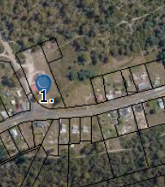
PIONEER
0-4 year olds | 0
5-14 year olds | 11
15-19 year olds | 11
TOTAL CHILDREN AND YOUNG PEOPLE  (remained the same since 2016) | 22
TOTAL NUMBER OF RESIDENTS  (Decrease of 10 since 2016) | 79
(2021 Census Data)

There is 1 playground space in Pioneer.

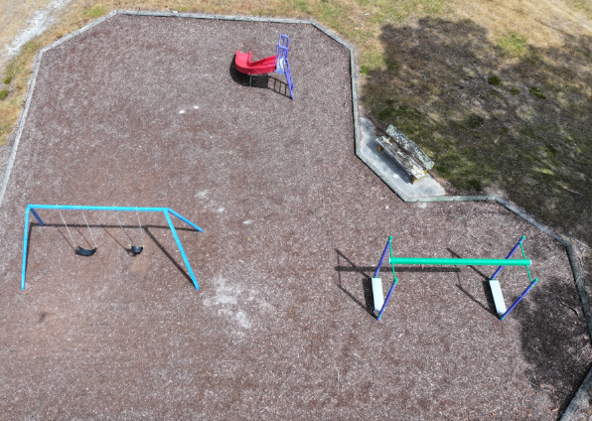
Pioneer Hall
The Pioneer Hall playground has no equipment targeted at the Infants/Toddler age group. The equipment that is there is restricted to single usage equipment such as a slide and swing.
Public toilets and parking are available at the Hall. Access is flat.
Playground is unfenced and set back 25m from main road and 15m from side road.
Equipment | Installed | Target Age Group
Equipment | Installed | 0-2 | 3-5 | 6-12 | 13+ | A
Double Swing | 1998
Aeroglide | 2007
Curved Solo Slide | 2007

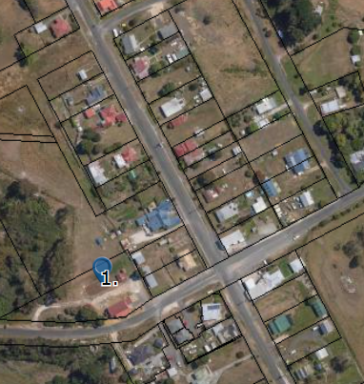
GLADSTONE
0-4 year olds | 4
5-9 year olds | 3
10-14 year olds | 8
15-19 year olds | 0
TOTAL CHILDREN AND YOUNG PEOPLE  (Decrease of 30 since 2016) | 15
TOTAL NUMBER OF RESIDENTS  (Decrease of 15 since 2016) | 124
(2021 Census Data)
There is 1 playground space in Gladstone.

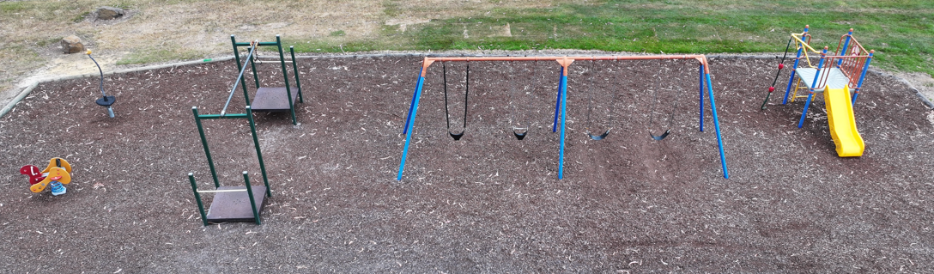
Gladstone Park
The Gladstone Park has no equipment targeted at the Infant/Toddler age group and limited equipment for teenagers. It is located adjacent to the Gladstone Hall.
Toilets and parking are available at the Gladstone Hall. Access is flat.
Playground is unfenced but set back behind Gladstone Hall away from the road.
Equipment | Installed | Target Age Group
Equipment | Installed | 0-2 | 3-5 | 6-12 | 13+ | A
Combination Play Equipment | 2002
Quad Swing | 2002
Flying Fox | 2002
Spring Toy – Bird | Unknown
Jumping Stick | Unknown

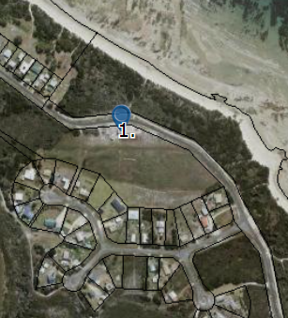
TOMAHAWK
0-4 year olds | 0
5-14 year olds | 0
15-19 year olds | 0
TOTAL CHILDREN AND YOUNG PEOPLE  (Decrease of 4 since 2016) | 0
TOTAL NUMBER OF RESIDENTS  (Increase of 6 since 2016) | 54
(2021 Census Data)
There is 1 playground space in Tomahawk.

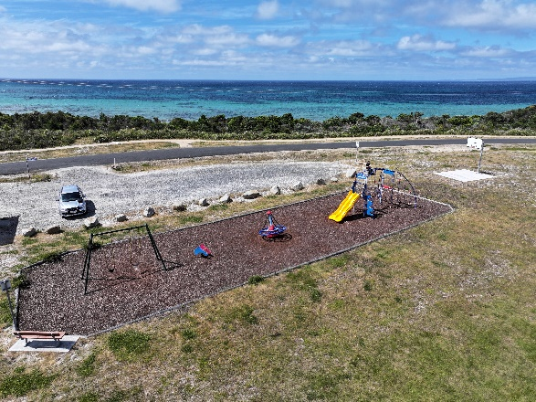
Tomahawk Reserve and BBQ Area
Tomahawk Reserve has a good selection of equipment to suit different ages. Usage is generally from visiting families and campers at the Tomahawk Caravan Park. Consideration could be given for future equipment to target the Infant/Toddlers age range. As a coastal area there is issues with corrosion at this playground with the equipment needing to be checked regularly.
Toilets and parking are both available on site at the playground. Access is flat.
Playground is unfenced and set back 20m from the road and 4m from the carpark.
Equipment | Installed | Target Age Group
Equipment | Installed | 0-2 | 3-5 | 6-12 | 13+ | A
Swing | Unknown
Spring Toy (Dolphin) | Unknown
Combination Play Equipment | 2011
Comet Spinning Wheel | 2011
Basketball hoop | Unknown

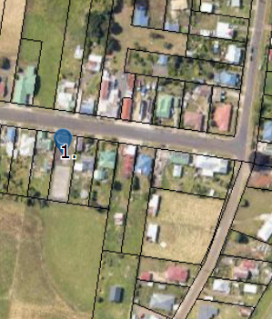
WINNALEAH
0-4 year olds | 12
5-9 year olds | 8
10-14 year olds | 22
15-19 year olds | 8
TOTAL CHILDREN AND YOUNG PEOPLE  (Increase of 15 since 2016) | 50
TOTAL NUMBER OF RESIDENTS  (Remained the same since 2016) | 225
(2021 Census Data)
There is 1 playground space in Winnaleah.

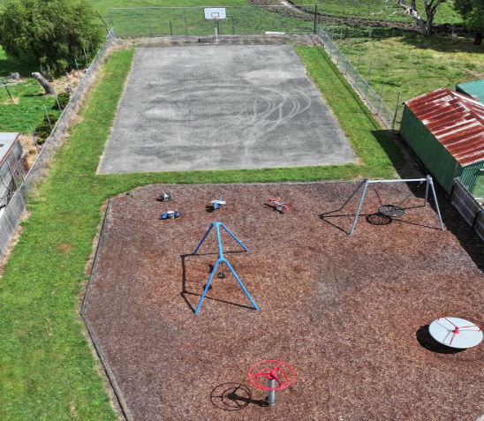
Main Street Playground
Winnaleah Park has a good selection of equipment for Early Childhood and School Age groups but consideration could be given for additional equipment pieces for Infant/Toddlers. There is a basketball court available for the teenage age groups.
Toilets are available 60m across the road at the Winnaleah Hall. Parking is available on street outside the playground. Access is flat. There is a BBQ available for use. The playground lacks shade, seating and any vegetation. Playground is fenced.
Equipment | Installed | Target Age Group
Equipment | Installed | 0-2 | 3-5 | 6-12 | 13+ | A
Double Swing | 2003
Spring Toy (Minibike) | 1998
Spring Toy (Kangaroo) | 1998
Spring Toy (Plane) | 1998
Spring Toy (Junior Rocker) | 2003
Carousel with Bars | Unknown
Birds Nest Swing | Unknown
Sky Ring Carousel | Unknown

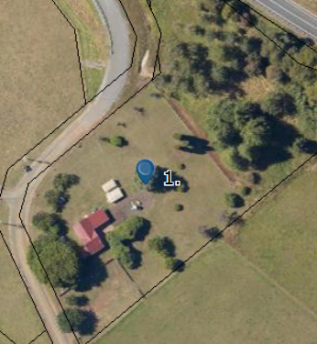
JETSONVILLE
0-4 year olds | 10
5-9 year olds | 7
10-14 year olds | 6
15-19 year olds | 9
TOTAL CHILDREN AND YOUNG PEOPLE  (Decrease of 8 since 2016) | 32
TOTAL NUMBER OF RESIDENTS  (Increase of 10 since 2016) | 147
(2021 Census Data)
There is 1 playground space in Jetsonville.

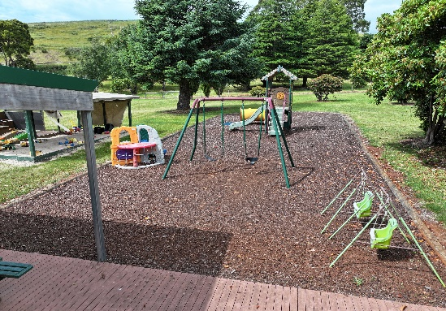
Jetsonville Hall
The Jetsonville Hall is well equipped and is home to the Jetsonville Playgroup. The majority of the equipment is targeted at the younger age groups up to the age of 5.
Toilets, parking at drinking water is available at the Hall. Access is flat and there is plenty of seating and shade.
Playground is fenced.
Equipment | Installed | Target Age Group
Equipment | Installed | 0-2 | 3-5 | 6-12 | 13+ | A
4 seat Seesaw | 2008
Yellow Tunnel | Unknown
Combination and Slide | Unknown
Double Swing | 2008

3. FINDINGS
The consultation period identified that the top 4 most popular playgrounds in Dorset were:
1. Lions Adventure Playground and Skate Park Area, Bridport foreshore
Why we love it:
  - Good variety of equipment to suit all ages
  - Good amenities – toilets, shade, picnic tables, water
  - Good location and access
What we could do to make it better:
- Fencing between the play area and the road
- More Baby/Toddler equipment
- Water play area
- Plants/Green space
- Shade over picnic tables
- More seating
- Better parking for skate park area
2. Children’s Reserve (Anzac Park), Scottsdale
Why we love it:
  - Location
  - Good equipment for younger children
  - Toilet and BBQ
  - Green space – grassy hills, lawn and gardens
  - Bike track
  - Enclosed park (safe)

What we could do to make it better:
- More shade
- More BBQ/seating
- More nature focus play
- More equipment – swings, tunnel, climbing structures, basketball space, etc
- Toilet upgrade
- Water refill station
- Bike track around the perimeter causes issues when kids are crossing
3. Elizabeth/Ethel Street Park, Scottsdale
Why we love it:
  - Access
  - Space and range of activities
What we could do to make it better:
- BBQ
- More equipment
- Toilet
4. Northeast Park, Scottsdale
Why we love it:
  - Ducks
  - Variety of activities – playground, outdoor exploring, bushwalks, ponds, wildlife, BBQ’s and toilets
What we could do to make it better:
  - Shade and seating
  - Better pond maintenance to clear blockages and prevent flooding
The consultation process also indicated that the most important facilities and/or elements to include in a playground were:
- Nature based open ended play options – trees, rocks, logs, landscaping etc
- Amenities – Toilets, water, picnic tables and seating, BBQ’s
- Diverse equipment for all age groups and abilities– encourage safe, risky play
- Safety - Secure fencing – particularly for younger children and in playgrounds near busy roads.
- Slides and swings for different age groups, zip lines, in ground trampolines, cubby houses, climbing options, sand play, water play, treasure trails and obstacle courses
- Good shade cover
Some of the key themes identified as a result of the consultation process include:
- Our playgrounds should include a variety of elements - not just play equipment but natural elements such as paths, landscaping and vegetation that enhance the area and create play and exploration opportunities. Nature based play is a much needed element – rocks, logs, equipment built into the environment. Water and sand play could be included in some playgrounds.
- Amenities are an important element in play spaces. Shade and seating are important components that need to be included for those watching and those needing to take a break from play. Ensuring our main parks have enough BBQ areas and picnic tables as well as drinking water. Baby change facilities are required.
- Playgrounds lack diversity from park to park – people would travel to a playground if it offered a unique experience from the one in their local area.
- Consolidation of smaller playgrounds should be considered in areas such as Bridport Foreshore and smaller localities such as Branxholm. This would reduce maintenance and renewal costs for playgrounds that don’t receive much usage.
- A focus should be on providing holistic, multi-generational, multi-use community hubs that provide areas for informal gatherings, relaxing and play. Particularly in rural localities where encouraging community connections is vital. Having localised multiuse green spaces are a key element in supporting community liveability.
- There is a lack of equipment across Dorset catering for those with a disability and for the infant/toddler age bracket. More emphasis could be placed on ensuring toddler spaces are safe (fenced) and even separate from older children play spaces.
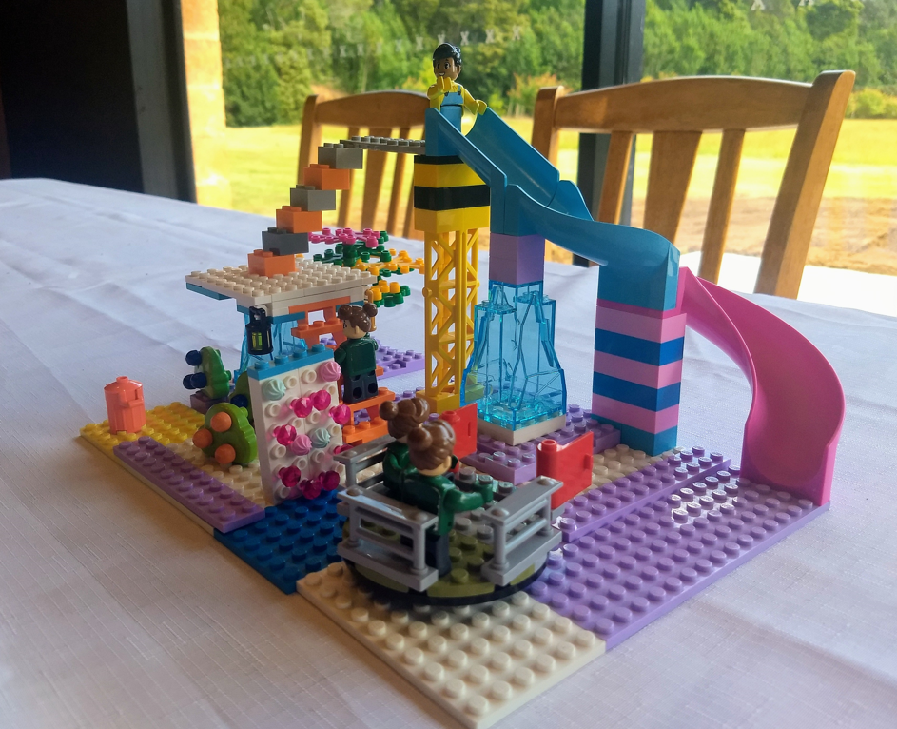
Playground Competition Winner – Kinder to Grade 2 – F Whyte

4. STRATEGIES and RECOMMENDATIONS
- Diversify our play spaces to enhance value and choice – identify ‘themes’ for each of the playgrounds and ensure the equipment ranges from park to park.
- Ensure there is diversity in the style and type of play equipment and elements provided at each park – there is currently a narrow range of equipment provided at the smaller playgrounds (swing, slide and spring toy)
- Include natural elements within play spaces– rocks, logs etc and include trees and landscape elements into play areas.
The following recommendations and associated timeframes have been identified and take into account age of equipment, community demographics, visitation and community feedback from the consultation process:
Short Term Recommendations (within the next 6-12 months):
- Replace main equipment elements at the Children’s Reserve, Scottsdale – helicopter and combination play equipment. Install additional play elements such as basketball court, natural play elements, seating and landscaping. Include accessible equipment as well as items for younger age. Concept plan to be developed and consultation to occur.
- Replace main equipment at Branxholm Park – combination play equipment. Concept plan to be developed and consultation to occur.
- Update Winnaleah Park to include additional landscaping, and play elements. Concept plan to be developed and consultation to occur.
Medium Term Recommendations (within the next 1-2 years):
- Investigate the feasibility of consolidating the following smaller playgrounds:
  - Bentley Street, Tennis Courts and Opposite the RSL into the Lions Adventure Playground, Bridport to increase the range of equipment available at the Lions Adventure Playground and decrease maintenance and costs associated with playground upgrades. (Investigate feasibility of installing a interactive ‘trail’ alongside the foreshore including art/sensory/adventure style equipment/activities to compensate for less formal playgrounds along the foreshore area.)
  - Branxholm Recreation Ground into Branxholm Park to decrease maintenance and costs associated with playground upgrades. (Demographics currently do not warrant two playgrounds in Branxholm.)
- Investigate the provision of full or part fencing in key playgrounds including:
  - Lions Adventure Playground, Bridport
  - Derby Park Playground
- Prepare business case to upgrade Scottsdale Skate Park
- Install playground elements targeting Infant/Toddler age range at Spotswood Drive Playground.
- Install additional playground elements in particular those targeting Infant/Toddler age range at Winnaleah Park Playground.
- Increase options for accessible play across:
  - Lions Adventure Playground, Bridport
  - Children’s Reserve, Scottsdale
- Investigate upgrade and/or improvements to the following playgrounds:
  - Tomahawk Reserve
Long Term Recommendations (within the next 2+ years):
- Investigate upgrade and/or improvements to the following playgrounds:
- McLennan Street, Scottsdale
- Elizabeth/Ethel Street, Scottsdale
- Ringarooma Recreation Ground Playground
- Pioneer Hall Playground
- Gladstone Hall Playground
- Upgrade Lions Adventure Playground to include additional landscaping, shade and seating plus additional play elements.

ABS 2017/2018

